
NOTTS
NARPO
NEWS

ISSUE 144 Summer 2019

CENTENARY COMMEMORATIVE MEDAL

As you know to commemorate our Centenary we have produced a limited amount of Commemorative Medals which are now on sale via the website at our Centenary shop at:

https://www.narpo.org/merchandise/ priced at £12.95 including postage and packaging.

A limited number will be available at Conference priced at £10 as there will be no postage and packaging costs involved.
The medals are selling well so if you wish to purchase one or more please do so at the earliest opportunity as they are sold on a first come first served basis.
- 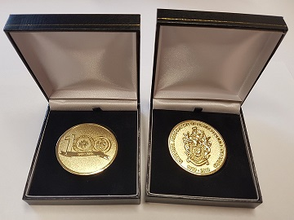
***********************************************
A Stepping Stone to Better Mental Health and Wellbeing

NARPO member, retired PC Roger Barker tells his story:
I joined Nottinghamshire Police in July 1982, first nick being Central, transferred to Force Support in January 1988 and moved to the Dog Section in summer 1993, finally having to retire in March 2009 on a medical.
On a couple of occasions since leaving the job and after an acrimonious marriage breakup, I felt so worthless I was close to taking my own life, but thankfully never followed through. I decided that one of the best ways for me to rid myself of the stigma surrounding my mental health was to be very open about my issues, especially when speaking to former colleagues.

To my surprise I discovered that several people came forward and thanked me for my openness and wanted to share their experiences, but had not felt strong enough to seek medical help. I thought if these people had come forward then how many more might there be? This is where the idea for the Stepping Stone Café came from.

Whilst not a professional counsellor and not pretending to be one, I saw there was a need for a half-way house where ex colleagues could come to have an informal cuppa and discreetly discuss their issues with someone who had an understanding of their situation. As this has developed it has become apparent that many officers have struggled with their role within the service or the way the job has treated them as they have approached the end of their service life, which has impacted badly on their respective retirements.

All I have sought to do is act as a stepping stone for them to maybe find a way forward to help them back to being their normal selves and enjoy life after service.
I now run my own business and this is where I host the Stepping Stone Café:
Roger Barker Slots. Unit 3, Old Great North Road, Sutton on Trent. NG23 6QS

I try to have an open door every Wednesday Morning between 10am and 12midday, but sometimes have to vary this because of work commitments. I confirm the forthcoming week’s opening times on the Facebook Page called:
‘Nottinghamshire s finest and a few other ….a social site!’
This is a ‘Secret Site’ on Facebook run by Ruth Woodcock; any member of the site can nominate new members for Ruth to add.

Nottinghamshire NARPO is pleased to support this fantastic initiative and we have awarded Roger a small grant to assist with the costs of refreshments. Additionally, if any member would like to attend, but is unable to do so because of transport difficulties, please contact the NARPO Branch Secretary and we will try to identify a committee member or volunteer driver to help you.

*****************************************************
DEDUCTIBILITY OF INCAPACITY BENEFIT AND INDUSTRIAL INJURY DISABLEMENT BENEFIT

There has been a recent decision at the Court of Appeal in Evans & Ashcroft v Chief Constable of South Wales Police and the impact this will have on the many injury retired officers who may have had their injury pensions over-deducted since 2010.
Constabularies have an obligation to take steps to refund the monies which have been unlawfully deducted and the Police Federation has produced a questionnaire for retired officers to work out whether they may be eligible for a refund. For those that consider they are, your secretary has a template letter for former officers to edit and send to the Chief Constable.

Please contact John Kennedy (details on Membership Page) for more information or visit www.narpo.org where more information can be found.

*************************************************************************

NARPO DIARIES
The order has been placed for NARPO Diaries and will be despatched to all members on the circulation list, if you are not on that list due to change of address or have declined the National Narpo Magazine sadly you will not receive one, if you do receive one and do not want it, please redirect the envelope to the Branch Secretary John Kennedy, 9 Jessops Lane, Gedling, Nottingham, NG4 4BQ and they will be distributed to new members who were not on the list as of 1 July 2019.

You should receive the diaries late October early November.

***************************************************************************
Ladies Day

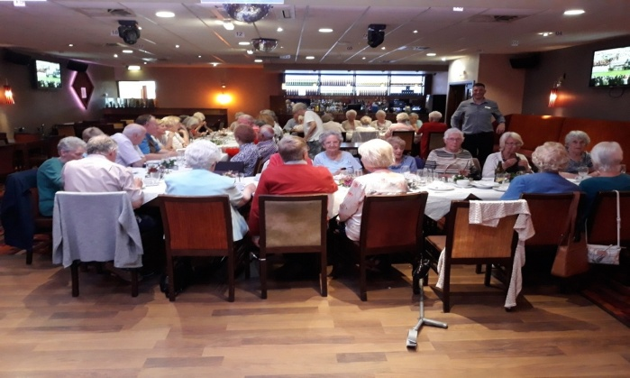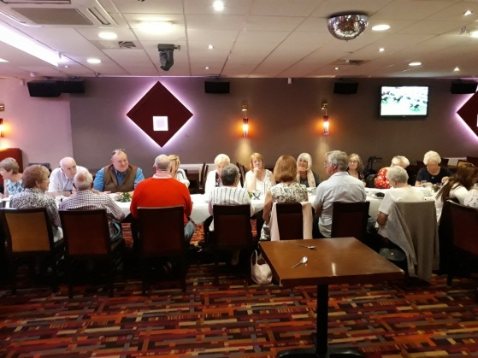

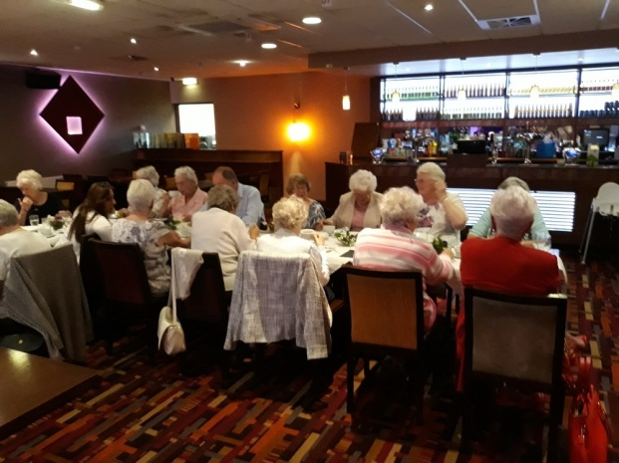
Ladies Day at the Stadium Leisure Club, a great afternoon enjoyed by all
**************************************************************************
NARPO RECRUITMENT LETTER
NARPO are initiating a recruitment drive for non-members who are in receipt of a Police Pension. XPS, the pensions administrator will, over the next few months, send a letter to all police pensioners who do not have a NARPO subscription deducted from their pension.

We would like to apologise to those members who pay a yearly subscription by direct debit or cheque, and life members, as they too will receive the letter, please ignore it.
NARPO CENTENARY BOAT TRIP
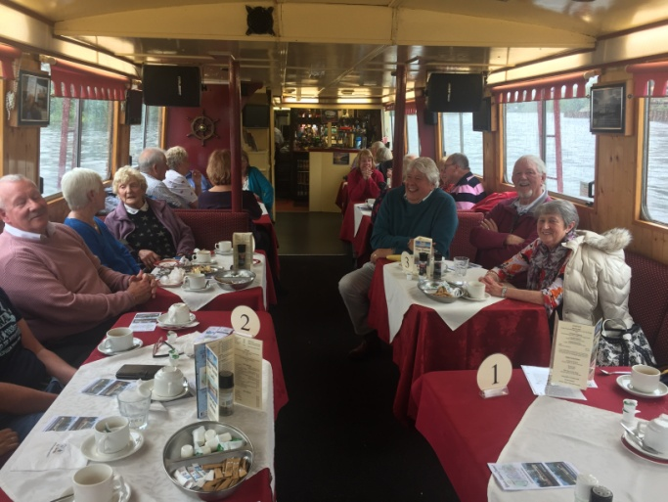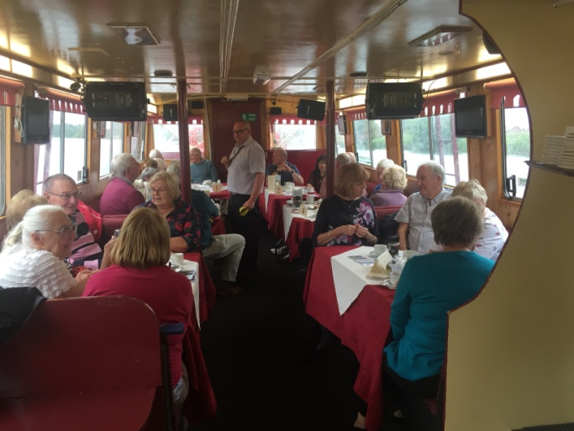
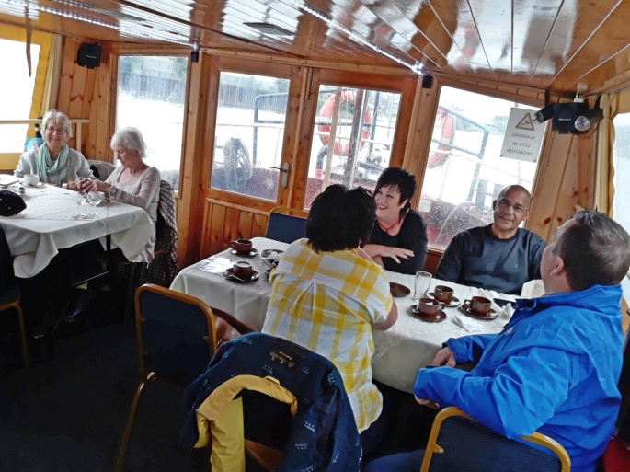

NARPO Trips and Social Events
Good Food Show.
This is on Thursday 28 November 2019 and it is at the Birmingham NEC. This trip will be free to NARPO Members.
The pickup points will be Carlton, Hucknall, and Mansfield. Times to be announced later.
Priority will be given to members and any non-members will be put on a reserve list pending vacancies. Non-members will be charged £10.00 plus the entrance ticket.
If you are interested in going please let Brian Marshall know at nottinghamshirenarpo@gmail.com or write to 4 Hartington Avenue, Hucknall, Notts

Summer Social

The Summer Social is due to take place at Ramsdale Park Golf Club, Calverton on Friday 30th August 2019, places are still available if interested contact Brian Marshall on nottinghamshirenarpo@gmail.com or 4 Hartington Avenue, Hucknall.

Cost of the Social is £5 per person, Hot Beef or Pork Cobs, Chips and a Dessert

ANNUAL REUNION DINNER

The Annual Dinner is to be held on Friday 6th December 2019 at Ramsdale Park Golf Club, tickets will remain at the same price as last year, as this is NARPO Centenary Year let’s make it special.

If you wish to attend please use the tear off slip below or email Nottinghamshirenarpo@gmail.com.

We do try to sit people together so if you want to sit with someone special please let us have details, or why don’t a group of you get together and book a table of 10.

I wish to attend the Annual Dinner on Friday 6th December 2019 at Ramsdale Park Golf Club, Calverton
Name__________________________________

Contact Details__________________________

Guest Names _____________________________________

Special Dietary Arrangements_______________________

I enclose Payment of £17.50p per person

Please forward to John Kennedy, 9 Jessops Lane, Gedling, Nottingham, NG4 4BQ or Email nottinghamshirenarpo@gmail.com

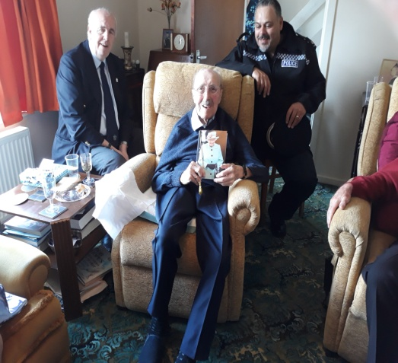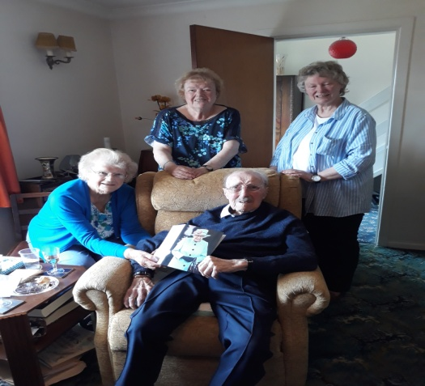

Edward Birtles celebrated his 100th Birthday on 23rd May; he had visits from the National President and our Branch Chairman Brian Burdus, Supt Rodgers from Bassetlaw together with Royal Greeting from Her Majesty the Queen and his family

He joined the RAF at the age of eighteen (National Service) and served during WW2 as a wireless Operator in the Middle East chasing Rommel about. After the war he went to join the City Police at the Guildhall. As he was not tall enough they tried to stretch him a little but not enough and they told him to go across to the Shirehall as the County Force would have him.
He served at Kirkby in Ashfield, Selston, Rural at Sutton on Trent covering five villages, Langold, Worksop and finally Retford from where he retired as Inspector on 21st May1977

MEMBERSHIP PAGE
COMMITTEE
MEMBERS.

President:
The Chief Constable.
Chairman
Brian Burdus
Secretary
John Kennedy
Tel 0115 8409277
Mobile 07851430645
nottinghamshirenarpo@gmail.com
9 Jessop’s Lane
Gedling
Nottingham
NG4 4BQ
Vice Chairman
Bruce Cameron
Ass Secretary
Brian Marshall
Tel 0115 9556563
nottinghamshirenarpo@gmail.com
Committee Members:
David Wheeldon
Ged Clowes
Marian Alflatt
Brian George
Heidi Duffy
Carolann Henderson
Anne Berrington
Tony Berrington
Anne Evans
Keith Newman
Dorothy Newman
Malcolm Holmes

A warm welcome is extended to the following new members:
Lee Hussey, Douglas Ing, Nikki Shore, Roger Barker, David Lowe
Steven M Smith, Sandra Fowkes, Christopher Barnes, Carl Bott,
Michael Marshall, Adrian Terrey. Grace Spicer

It is with regret that I have to inform you of the death of the
following members since our last publication. Our deepest sympathies are
extended to their next of kin:

Members Retired. Date Retired. Died
Martin Tupman Sergeant 31/10/93 23/4/19
William Teece Constable 16/05/77 16/4/19
John Sawyer Sergeant 24/9/73 24/4/19
Derek Laws Inspector 1/2/78 2/5/19
David Bombroffe Superintendent 5/5/11 1/5/19
Robert Marsden Sergeant 16/8/75 16/7/19
John Wing Constable 4/1/94 10/5/19
Victor Warden Constable 1982 7/6/19
John Burnett Sergeant 1/9/85 3/6/19
Brian Clewer Constable 6/9/83 27/6/19
Herbert Spicer Sergeant 31/10/79 15/7/19
John Westwood Sergeant 9/8/99 6/7/19
Colin Smith Sergeant 31/8/79 18/7/19
Peter Witt Constable Not Known 6/7/19
Jeanette Hooper Superintendent 1985 16/7/19
Stuart Rogerson Constable 8/11/86 13/7/19

Widow Members: Died Widow of:-
Edith Storer 5/1/19 Willie Storer
Olwen Buckberry N/K Ivan Buckberry
Marie Skinner 30/4/19 Alan Skinner
Sadie Clarke 16/4/19 Nobby Clarke
Jean Wilson 15/5/19 Dennis (Tug) Wilson
Marjorie Merry 22/5/19 Alan (skip) Merry
Dorothy Smith 15/6/19 Leonard Smith

100 Years Young - Norren McCullough is 100 years young on 11th September 2019; Noreen is the widow of Thomas McCullough, congratulations from all at NARPO

Wedding Anniversary - Mick and Delma Soult were married at Queensbury Street Baptist Church, Basford on the 26th September, 1959. - Congratulations on your Diamond Wedding, Notts NARPO and members

Peter and Mary Abbey celebrated 66 years of married bliss on 21st March this year. Congratulations on your wedding anniversary, Notts NARPO and Members

